DEPARTMENT OF CHEMISTRY

Activities 2021-22

**Inter-Institutional Science Fair**

The students of M.Sc. Chemistry brought laurels to the Department of Chemistry by bagging top positions in various events in the Inter-Institutional Science Fair held at Multani Mal Modi College, Patiala on 14th November 2021 under the leadership of Dr. Yadwinder Singh Deol. Ms. Divya and Ms. Dinky, students of M.Sc.-2nd year won 1st prize in the working model category, Mr. Jaskaran and Praise (Both from M.Sc. 1st year) remained successful in bagging 3rd position in the static model category. Two more students, Mr. Rahul and Ms. Vasu, students of M.Sc.-1 got participation certificates in the Poster making competition.

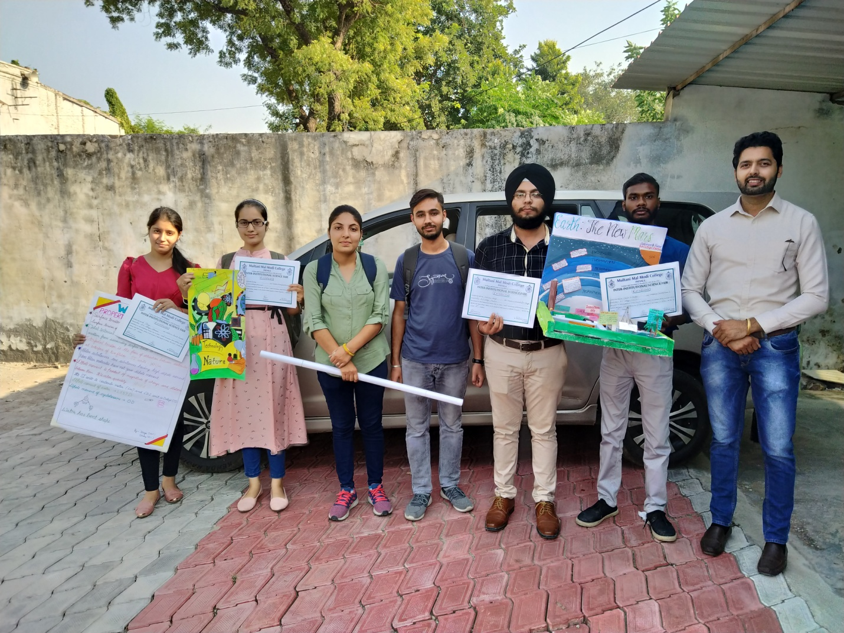

**Declamation Contest**

The Chemical Society organised a declamation contest on the topic-‘Humans will Soon become Slaves of Machines’ on November 23, 2021. 21 students of B.Sc. and M.Sc. Chemistry participated in the contest. The contest was organised by Prof. Monika Thakur and Dr. Yadwinder Singh Deol. Dr. Sanjay Talwani, Head of Biology Department and Dr. Manish Garg, Head of Physics Department were the judges for the contest. Ms. Komal of B.Sc III, Mr. Harshdeep Tiwari of BSc III and Mr. Saddi of B.Sc. I won first, second and third positions respectively in the contest.

**Chemistry Faculty Award**

6th Chemistry Faculty Award was awarded to Ms. Ishita Aggarwal for scoring highest marks in Chemistry among all UG students of the college in the Annual Prize Distribution function organised on 29th April 2022. The prize carries a cash award of Rs. 5000, a trophy and a certificate. The prize money is contributed by Prof. Ravinder Jeet Singh, Dr. Manpreet Kaur, Prof. Monika Thakur, Dr. Rawel Singh and Dr. Yadwinder Singh Deol.

**Professor M.S. Hundal Academic Excellence Award**

Ms. Simranjot Kaur of MSc Chemistry got the 2nd Prof. M.S. Hundal Academic Excellence Award in the Annual Prize Distribution function organised on 29th April 2022. She stood first in the college and got 10th position in the University in MSc Chemistry 2021 examinations. The prize carries a cash award of Rs. 5000, a trophy and a certificate. The award is sponsored by Prof. Ravinder Jeet Singh in memory of his mentor and teacher Dr. M.S. Hundal former faculty and chairperson of Chemistry Department Guru Nanak Dev University Amritsar.

**Cheminformatics Workshop**

Two day workshop on Cheminformatics Workshop was organised on 17th and 18th May 2022. Seven students of BSc III participated in the workshop. Students learnt the application of Sanger’s method for solving the peptide structure of Insulin. Students successfully arranged the 51 amino acids in Chain A and Chain B of Insulin. Participants were also given an introductory knowledge of Avogadro Software, Protein Explorer, MDL Chime for 3D modeling of molecules by Prof. Ravinder Jeet Singh. Deepak Kumar (Roll No 3312), Utkarsh Maurya (Roll No 3306), Harjot Singh (Roll No 3002), Neha (Roll No 2908), Prabhjot Singh (Roll No 3303), Harmanjot Singh (Roll No 3310) and Raj Kumar (Roll No 3319) of BSc III participated in the workshop.

**Educational Tour I**

Chemical Society organised an educational trip to Barog, Solan on May 01, 2022. 42 students of 1st and 2nd Year of M.Sc. Chemistry accompanied by Dr. Yadwinder Singh Deol, Dr. Rawel Singh, Prof. Monika Thakur, Dr. Manpreet Kaur and Prof. Ravinder Jeet Singh went to the Railway Station Barog. Barog Tunnel (1100meters) is the longest tunnel on Kalka Shimla railway track. The bus departed from Samrala Chowk Khanna at 5.00 am. Students also visited Gurudwara Nadda Sahib and Mansa Devi en route to Barog. Students also went on trek of nearly 2km in search of the old tunnel. It is said that the tunnel was being build under the guidance of Er. Barog. The tunnel was supposed to be the longest tunnel in the world at that time. There was an error in calculation as tunnel was being built from both ends. But the ends of the tunnel did not meet and a fine of Rupee 1 was imposed on Er. Barog. Mr. Barog committed suicide using his revolver. The railway station and the village was named after Er. Barog as a mark of respect towards him. Students had dinner at Katani Dhaba. The bus fare from Khanna to Brog cost us Rs. 20000. The driver was very nice and Cooperative.

**Educational Tour II**

Department of Chemistry and Physics jointly organised a trip for BSc students. 42 students of BSc 3rd year went on a trip to Barog and Pinjore Garden on May 2022. The students were accompanied by Prof. Ravinder Jeet Singh, Dr. Manpreet Kaur, Prof. Monika Thakur, Dr. Rawel Singh and Dr. Yadwinder Singh Deol from Department of Chemistry. Prof. Jasdeep Kaur from Physics Department and Dr, Charn Kumar from Biology Department also accompanied the students. We reached Pinjore Garden at 6.00 p.m. However students were a bit disappointed as fountains were not fully functional due to falling number of visitors. It has been like this since COVID restrictions were imposed.

**World Environment Day**

The 8th Cycling Expedition of A.S. College Khanna since 2002 was organised today to mark World Environment Day as well as World Bicycle Day. A contingent of sixteen students and teachers was flagged off by the officiating principal, Dr. K.K. Sharma, at 5.00 a.m. on Sunday, 5th November 2022 .  NCC students also actively participated in the event. The cyclists carried placards for the promotion of cycling, a pollution-free environment and better health. The students visited the historic Gurudwara Shri Manji Sahib Kottan and Sarai Lashkar-e-Khan under the leadership of Prof. Ravinder Jeet Singh and Dr. Rawel Singh. The contingent travelled a distance of 50km on their bicycles. Students were interviewed by Dr. Charn Kumar on the way.  This event was organised as a part of the celebration of 75 years of Independence- Azadi Ka Amrit Mahotsav.

**German Language Course**

Simranjot Singh, Roll No 2013 and Ramanpreet Kaur, Roll No 1803 of BSc Ist year have successfully completed the course and qualified the German Language Exam in Non formal mode.